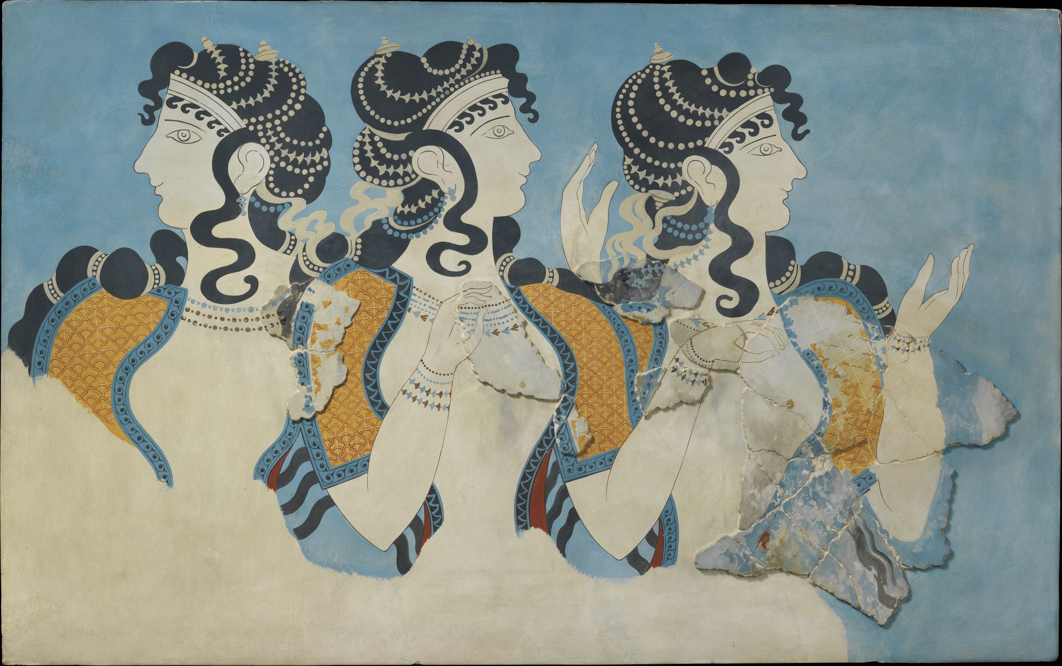  ‘Ladies in Blue’ Fresco - 1525 - 1450BCE Excavated before 1914 from Knossos Palace | 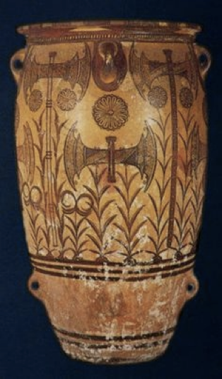  Minoan Art Labrys pithos – 1500BC Knossos Palace
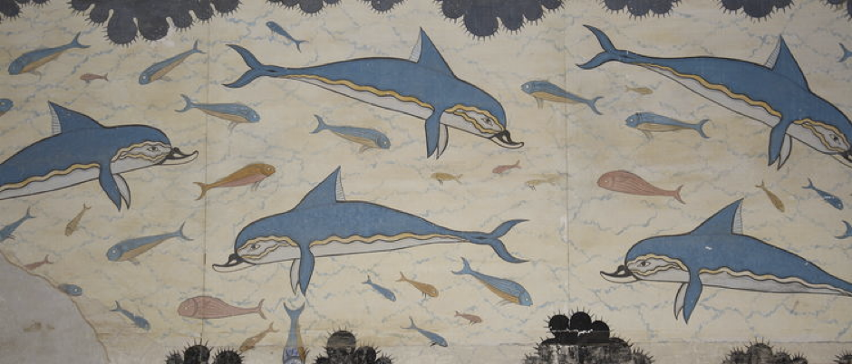  A detail of the dolphin fresco Minoan palace of Knossos, Crete, (c. 1700-1450 BCE) | 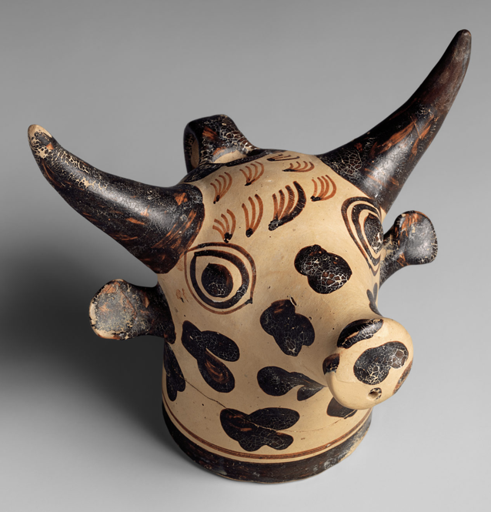  Bull head vase or libation vase (terracotta)
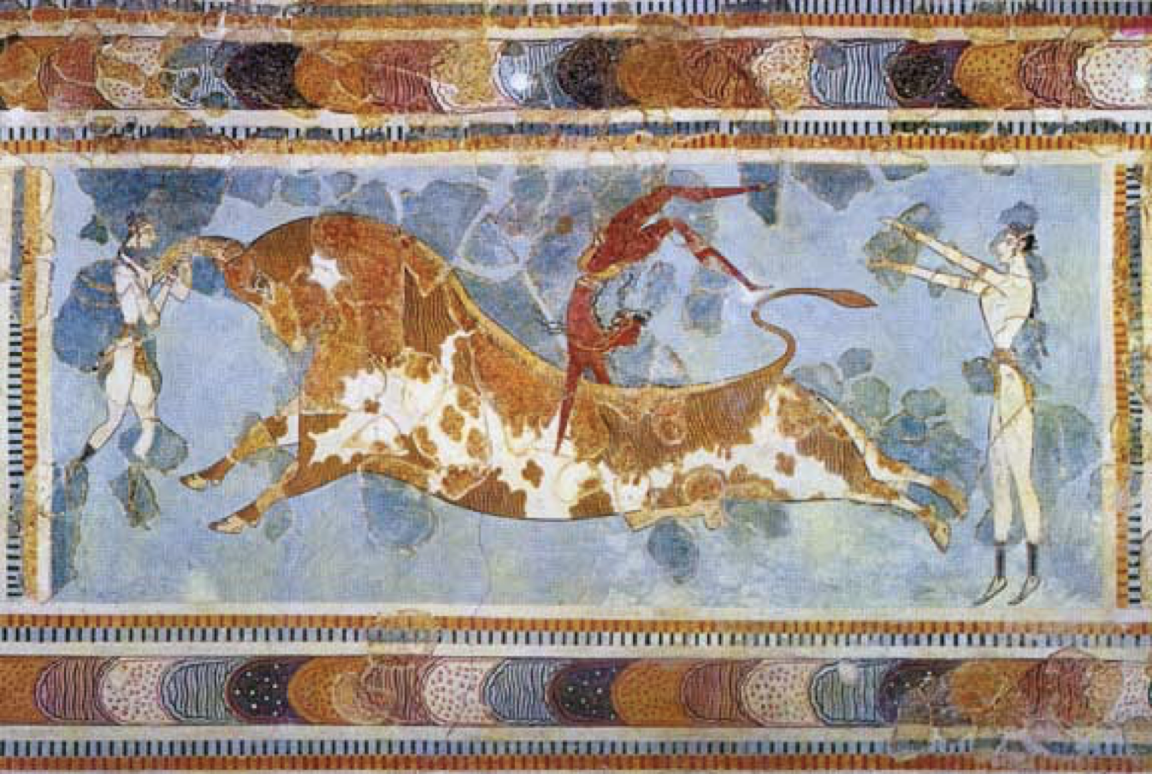  Bull-leaping fresco from the palace at Knossos | 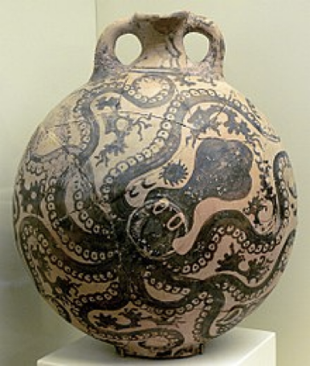  "Marine Style" flask with octopus, (c. 1500-1450 BCE)

